|  |  |
| --- | --- |
| Activity | Data Type |
| Number of beatings from Wife | Discrete |
| Results of rolling a dice | Discrete |
| Weight of a person | Continuous |
| Weight of Gold | Continuous |
| Distance between two places | Continuous |
| Length of a leaf | Continuous |
| Dog's weight | Continuous |
| Blue Color | Discrete |
| Number of kids | Discrete |
| Number of tickets in Indian railways | Discrete |
| Number of times married | Discrete |
| Gender (Male or Female) | Discrete |

**Q1) Identify the Data type for the Following:**

**Q2) Identify the Data types, which were among the following**

Nominal, Ordinal, Interval, Ratio.

|  |  |
| --- | --- |
| Data | Data Type |
| Gender | Nominal |
| High School Class Ranking | Ordinal |
| Celsius Temperature | Ratio |
| Weight | Ratio |
| Hair Color | Ordinal |
| Socioeconomic Status | Ordinal |
| Fahrenheit Temperature | Ratio |
| Height | Ratio |
| Type of living accommodation | Ordinal |
| Level of Agreement | Interval |
| IQ(Intelligence Scale) | Ratio |
| Sales Figures | Interval |
| Blood Group | Nominal |
| Time Of Day | Ratio |
| Time on a Clock with Hands | Ratio |
| Number of Children | Ordinal |
| Religious Preference | Nominal |
| Barometer Pressure | Ratio |
| SAT Scores | Interval |
| Years of Education | Ratio |

**Q3) Three Coins are tossed, find the probability that two heads and one tail are obtained?**

ANS :

Three coins are tossed then possible combinations :

| HHH,HHT,HTH,HTT,THH,THT,TTH,TTT |

Combinations with two heads and one tail :

| HHH,**HHT**,**HTH**,HTT,**THH**,THT,TTH,TTT |

No. of combinations with two heads and one tail : 3

Probability : 3/8 = **0.37**

**Q4) Two Dice are rolled, find the probability that sum is**

1. Equal to 1
2. Less than or equal to 4
3. Sum is divisible by 2 and 3

ANS :

Two dice are rolled then possible sums of probability is :

|2,3,4,5,6,7,8,9,10,11,12|

1. 0/11= **0**
2. 3/11=**0.27**
3. 8/11=**0.72**

**Q5) A bag contains 2 red, 3 green and 2 blue balls. Two balls are drawn at random. What is the probability that none of the balls drawn is blue?**

ANS :

Two balls are drawn randomly then possible combinations :

|R1R2,R1G1,R1G2,R1G3,R1B1,R1B2,R2G1,R2G2,R2G3,R2B1,R2B2,G1G2,G1G3,G2G3,G1B1,G1B2,G2B1,G2B2,G3B1,G3B2,B1B2|

Two balls are drawn randomly then no.of possible combinations = 21

Combinations that none of the balls drawn is blue :

|**R1R2,R1G1,R1G2,R1G3**,R1B1,R1B2**,R2G1,R2G2,R2G3**,R2B1,R2B2,**G1G2,G1G3,G2G3**,G1B1,G1B2,G2B1,G2B2,G3B1,G3B2,B1B2|

No.of combinations that none of the balls drawn is blue = 10

Probability that none of the balls drawn is blue :10/21=**0.47**

**Q6) Calculate the Expected number of candies for a randomly selected child**

Below are the probabilities of count of candies for children (ignoring the nature of the child-Generalized view)

|  |  |  |
| --- | --- | --- |
| CHILD | Candies count | Probability |
| A | 1 | 0.015 |
| B | 4 | 0.20 |
| C | 3 | 0.65 |
| D | 5 | 0.005 |
| E | 6 | 0.01 |
| F | 2 | 0.120 |

Child A – probability of having 1 candy = 0.015.

Child B – probability of having 4 candies = 0.20

ANS :

Expected number of candies for a randomly selected child :

1*0.015 + 4*0.20 + 3*0.65 + 5*0.005 + 6*0.01 + 2*0.120 = **3.09**

**Q7) Calculate Mean, Median, Mode, Variance, Standard Deviation, Range & comment about the values / draw inferences, for the given dataset**

* For Points,Score,Weigh>

Find Mean, Median, Mode, Variance, Standard Deviation, and Range and also Comment about the values/ Draw some inferences.

Use Q7.csv file

ANS :-

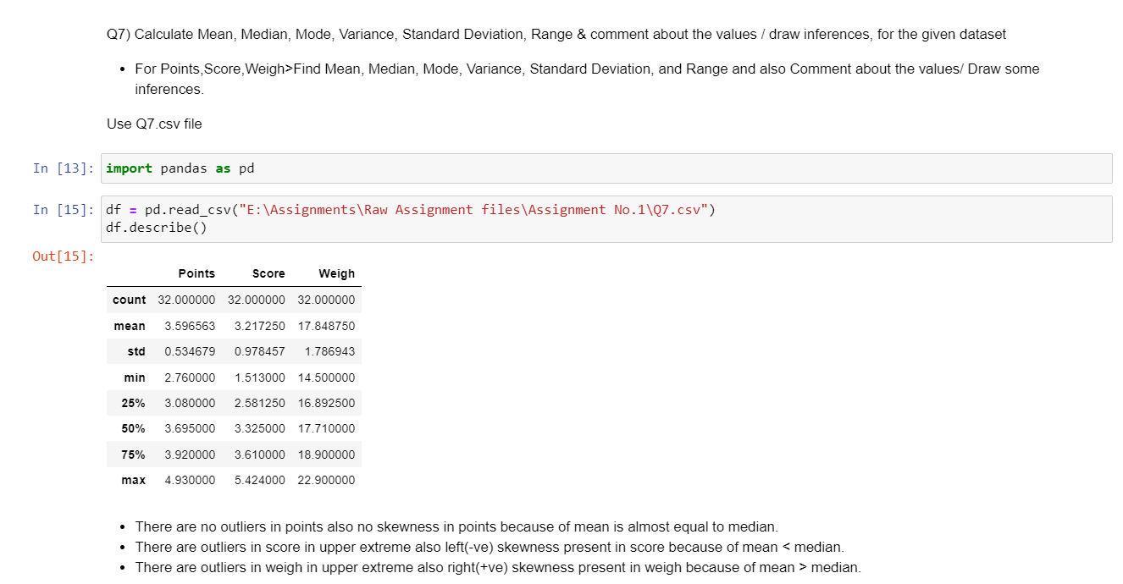

**Q8) Calculate Expected Value for the problem below**

1. The weights (X) of patients at a clinic (in pounds), are

108, 110, 123, 134, 135, 145, 167, 187, 199

Assume one of the patients is chosen at random. What is the Expected Value of the Weight of that patient?

ANS:

Weights=(108, 110, 123, 134, 135, 145, 167, 187, 199)

Probability = 1/9 =0.11

Expected Value of the Weight of that patient :

0.11*108 + 0.11*110 + 0.11*123 + 0.11*134 + 0.11*135 + 0.11*145 + 0.11*167 + 0.11*187 + 0.11*199

= **145.33**

**Q9) Calculate Skewness, Kurtosis & draw inferences on the following data**

**Cars speed and distance**

**Use Q9_a.csv**

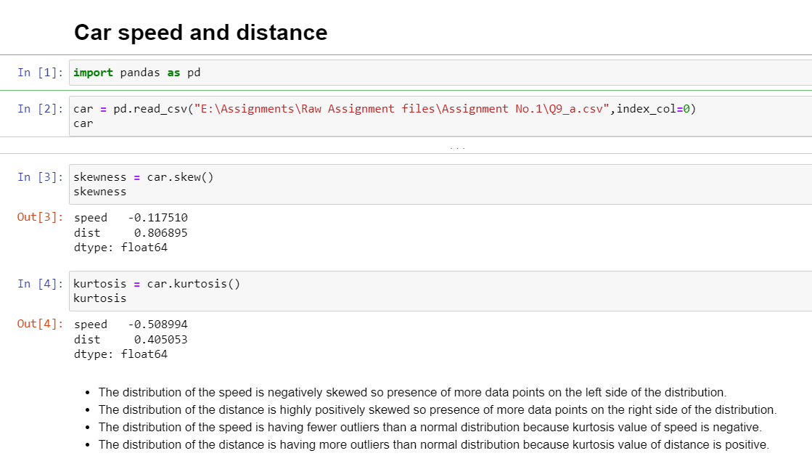

**SP and Weight(WT)**

**Use Q9_b.csv**

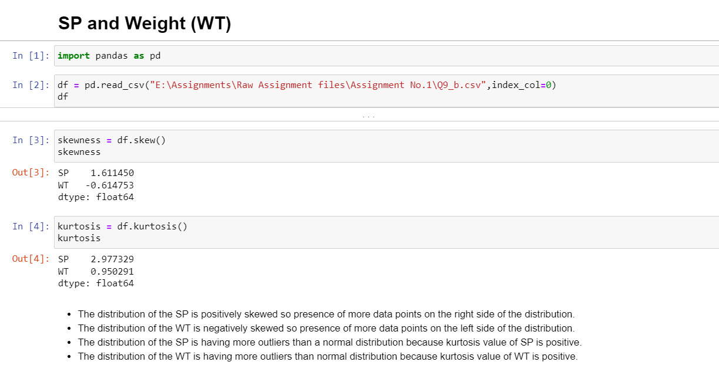

**Q10) Draw inferences about the following boxplot & histogram**



ANS :-

* The mean weight of the chicks will be higher than the median weight because the positive skew that there are a few outliers with high weight values that pull the mean upwards.
* The mode weight will be lower than the median and the mean weight because the majority of chicks have a lower weight.
* The histogram will have a longer tail on the right hand side because of the few chicks with high weight values.



* The boxplot has outliers on the upper side, it means that there are data points that lie above the upper wisker.
* The median of dataset may be shifted upwars, indicates that the central tendency of the data is higher than expected.

**Q11)** Suppose we want to estimate the average weight of an adult male in Mexico. We draw a random sample of 2,000 men from a population of 3,000,000 men and weigh them. We find that the average person in our sample weighs 200 pounds, and the standard deviation of the sample is 30 pounds. Calculate 94%,98%,96% confidence interval?

ANS :-

sample = 2,000, population = 3,000,000,

sample mean = 200, sample sd = 30

confidence interval 94% and alpha = 0.06 :

lower extreme : 200-st.t.ppf(0.97,1999)*30/math.sqrt(2000)

=198.7376

upper extreme : 200+st.t.ppf(0.97,1999)*30/math.sqrt(2000)

= 201.26

confidence interval 96% and alpha = 0.04 :

lower extreme : 200-st.t.ppf(0.98,1999)*30/math.sqrt(2000)

=198.62

upper extreme : 200+st.t.ppf(0.98,1999)*30/math.sqrt(2000)

= 201.378

confidence interval 98% and alpha = 0.02 :

lower extreme : 200-st.t.ppf(0.99,1999)*30/math.sqrt(2000)

=198.438

upper extreme : 200+st.t.ppf(0.99,1999)*30/math.sqrt(2000)

= 201.561

**Q12)** Below are the scores obtained by a student in tests

**34,36,36,38,38,39,39,40,40,41,41,41,41,42,42,45,49,56**

1. Find mean, median, variance, standard deviation.
2. What can we say about the student marks?

ANS :-

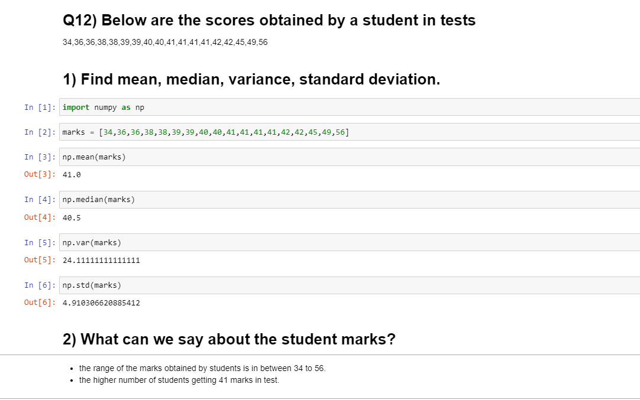

Q13) What is the nature of skewness when mean, median of data are equal?

ANS :- When the mean and median of data are equal then there is no skewness in data.

Q14) What is the nature of skewness when mean > median ?

ANS :- When the mean is greater than median then there is positive or right-hand skewness in data.

Q15) What is the nature of skewness when median > mean?

ANS :- When the median is greater than mean then there is negative or left-hand skewness in data.

Q16) What does positive kurtosis value indicates for a data ?

ANS :- positive kurtosis value indicates that a distribution has a higher peak and heavier tails than the normal distribution.

Q17) What does negative kurtosis value indicates for a data?

ANS :- Negative kurtosis value indicates that a distribution has a flatter peak and thinner tails than normal distribution.

Q18) Answer the below questions using the below boxplot visualization.



What can we say about the distribution of the data?

Ans – It is not a normally distributed.

What is nature of skewness of the data?

Ans – There is a negative skewness present in data.

What will be the IQR of the data (approximately)?

Ans – IQR of the data (approximately)is from 10 to 18.

Q19) Comment on the below Boxplot visualizations?



Draw an Inference from the distribution of data for Boxplot 1 with respect Boxplot 2.

ANS :-

Boxplot 1(approximately):-

1. Median : 262.5
2. Min : 240
3. Q1 : 260
4. Q3 : 280
5. Max : 290

Boxplot 2(approximately):-

1. Median : 262.5
2. Min : below 200
3. Q1 : 220
4. Q3 : 310
5. Max : above 325

Q 20) Calculate probability from the given dataset for the below cases

Data _set: Cars.csv

Calculate the probability of MPG of Cars for the below cases.

MPG <- Cars$MPG

* 1. P(MPG>38)
  2. P(MPG<40)

c. P (20<MPG<50)

ANS :-

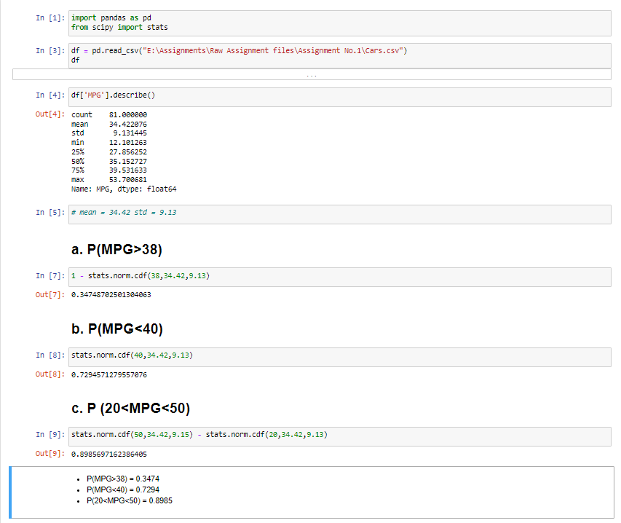

Q 21) Check whether the data follows normal distribution

1. Check whether the MPG of Cars follows Normal Distribution

Dataset: Cars.csv

ANS :-

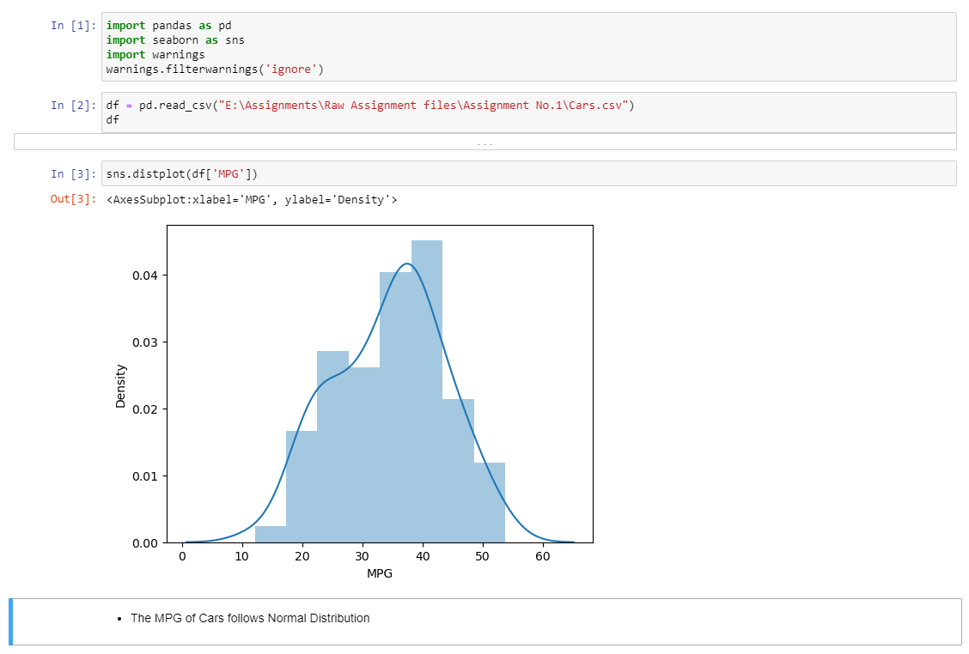

1. Check Whether the Adipose Tissue (AT) and Waist Circumference(Waist) from wc-at data set follows Normal Distribution

Dataset: wc-at.csv

ANS :-

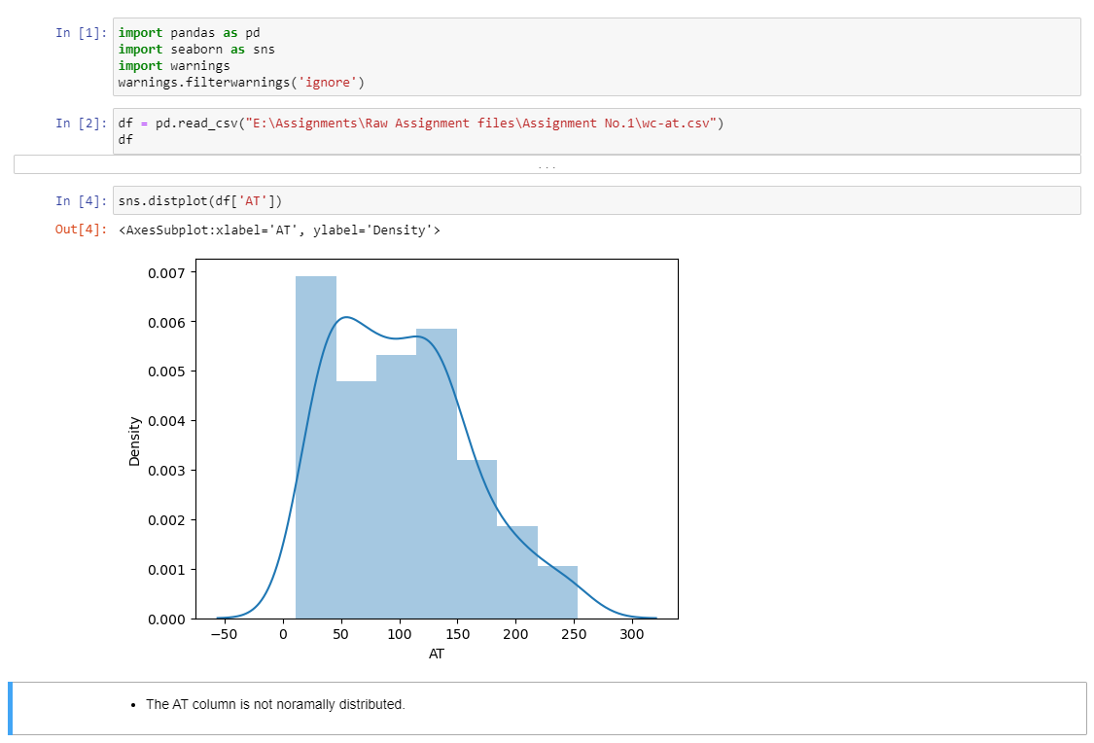

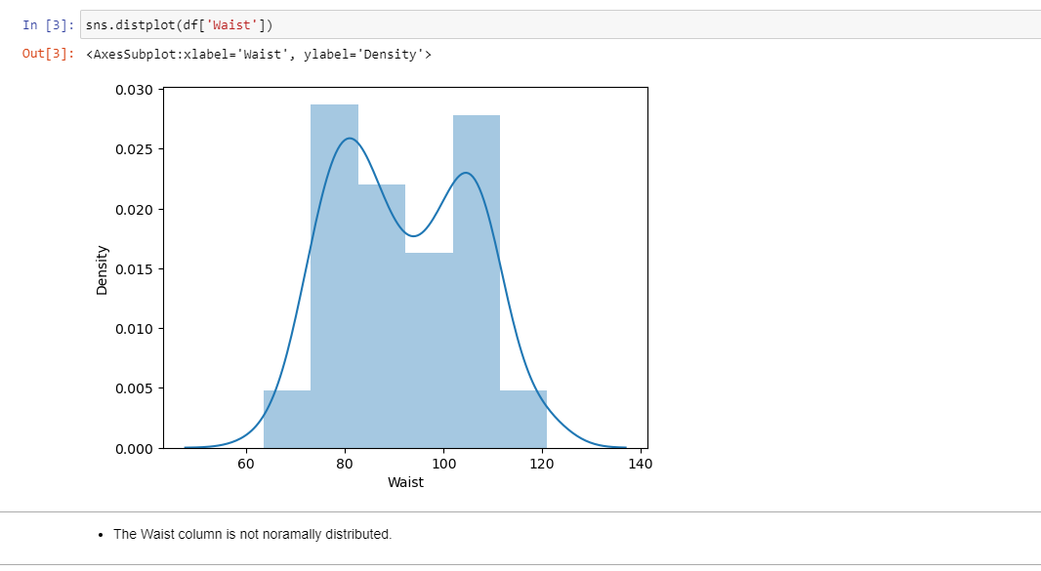

Q 22) Calculate the Z scores of 90% confidence interval,94% confidence interval, 60% confidence interval

ANS :-

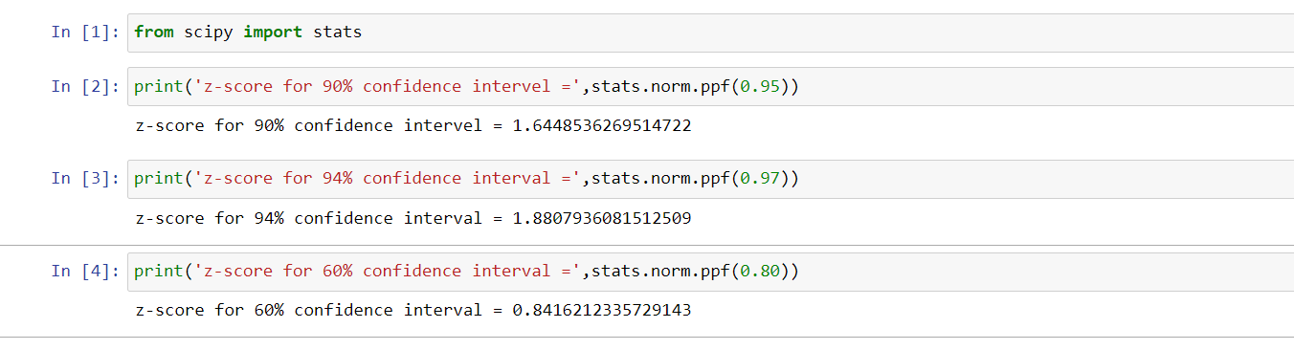

Q 23) Calculate the t scores of 95% confidence interval, 96% confidence interval, 99% confidence interval for sample size of 25

ANS :-

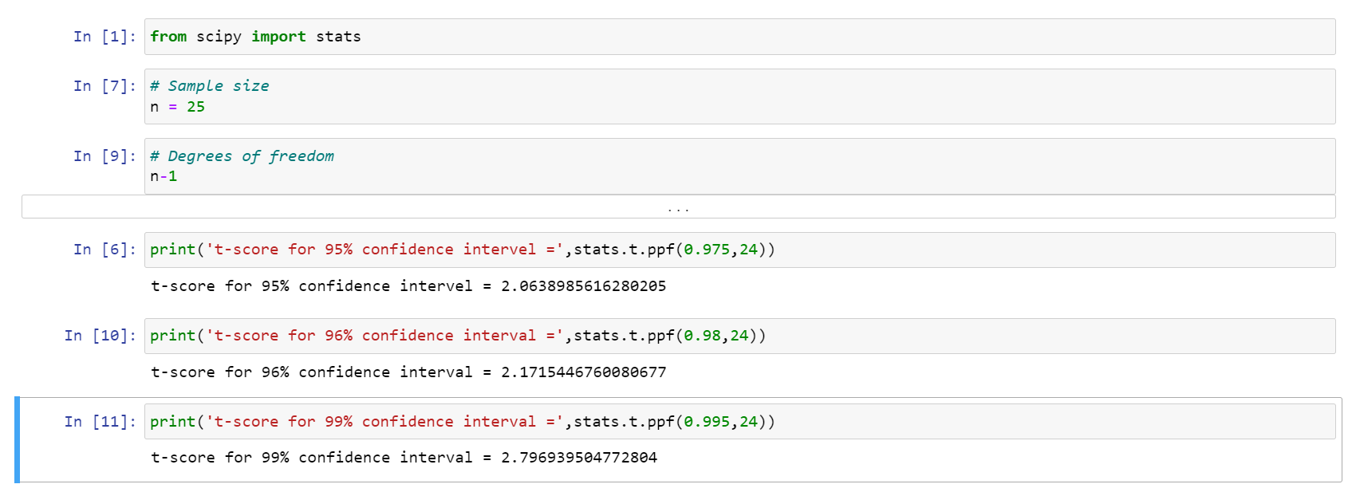

Q 24**)** A Government company claims that an average light bulb lasts 270 days. A researcher randomly selects 18 bulbs for testing. The sampled bulbs last an average of 260 days, with a standard deviation of 90 days. If the CEO's claim were true, what is the probability that 18 randomly selected bulbs would have an average life of no more than 260 days

Hint:

rcode 🡪 pt(tscore,df)

df 🡪 degrees of freedom

